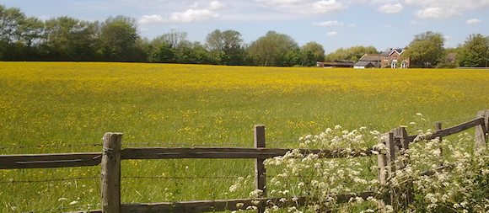IMPORTANT NOTICE

LANGSTONE ROAD CYCLING AND PEDESTRIAN INFRASTRUCTURE

Stage 2 of this project is starting on 1 October for 5 weeks. The works will take place on the western side of the carriageway between The Mallards and the entrance to the Langstone Technology Park. The major component of the work is the reshaping of the southern corner of the entrance to Langbrook Close. Attached is a copy of Havant Borough Council’s letter dated 3 September 2018, detailing the works.

EASTERN SOLENT COASTAL PARTNERSHIP – Proposed ground and structural investigation works - 2018

As part of the Langstone Flood and Coastal Erosion Risk Assessment Study, contractors will be carrying out works to establish the condition of existing defences and probe the ground in a number of places to gain data for future design work. These activities are due to commence on 17 September and last for 2 weeks.

A compound will be set up in a corner of The Ship Inn car park and works will focus on the areas shown in the photo below. Every effort will be made to minimise inconvenience, but everyone using the areas marked in red need to be aware and be careful when passing. More detail will follow.

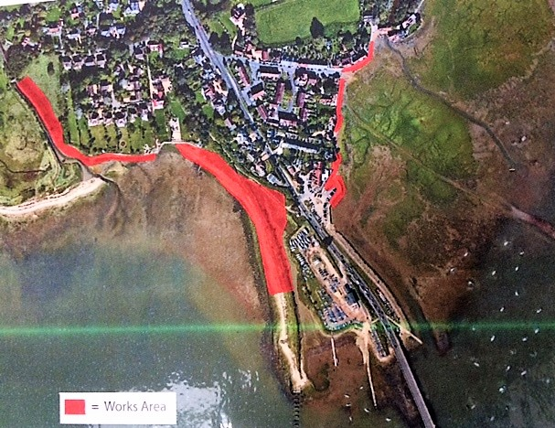 LRA/DGT/SEPTEMBER 2018

