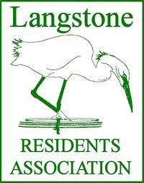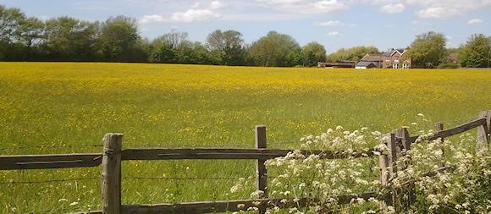
Angela Armstrong – Chairman – 19 Hamilton Close, LANGSTONE, Havant, PO9 1RP
David Pattenden – Secretary – 18 Southbrook Road, LANGSTONE, Havant, PO9 1RN

14 December 2018

Councillor Tim Pike
Havant Borough Council
Public Service Plaza
Civic Centre Road
Havant
PO9 2AX

Email address: tim.pike@havant.gov.uk

Our ref: DGTP/JRP

Dear Councillor Pike

The Railway Cottages, 59/61 Langstone Road

As you will know, tragedy struck this building for the second time in a month on Saturday/Sunday, the 8/9 December 2018. An extensive fire has consumed the timber structure leaving just the brickwork chimney stacks standing.

The Langstone Residents’ Association Committee met the next day and resolved to add its weight to the campaign to have this important local landmark rebuilt. The property, known locally as the Railway Cottages, has been a welcome visual highlight for walkers and motorists for decades. We have regularly asked Havant Borough Council to persuade the Owners to take better care of the building, noting its classification as a Grade II listed structure important for its historic value.

Members of our community were encouraged when the Cottages were recently sold and the new Owner stated they were to be renovated for occupation by a relative. Site clearance followed, but now this! No doubt a full investigation will be undertaken to establish just what did happen.

The LRA requests your personal involvement in this matter, as our elected representative on the Council, to ensure everything possible is done to have this important historical link restored. I attach a sheet setting out some facts about the building, prepared by our Historian Ann Griffiths, which may assist your advocacy for this project.

Yours sincerely

David Pattenden DipArch RIBA BTP
Secretary – LRA

cc Angela Armstrong – Chairman, Langstone Residents’ Association
LRA Committee
All Ward Councillors
HCC Councillor Ray Bolton

