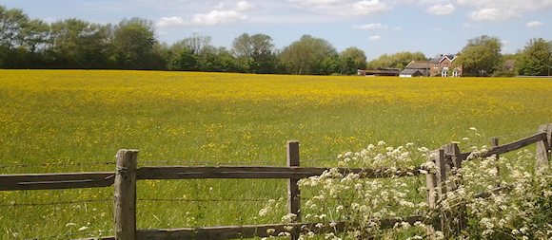IMPORTANT NOTICE

LANGSTONE TECHNOLOGY PARK
PLANNING APPLICATION – APP/19/00703
AUGUST 2019

Agents acting for the Owners of Langstone Technology Park have submitted a planning application for major changes to this site. See Havant Borough Council’s Planning page and application No APP/19/00703.

https://planningpublicaccess.havant.gov.uk/online-applications/applicationDetails.do?activeTab=documents&keyVal=DCAPR_246448

Note, the period during which public comment may be made ends on 3 September, in less than 3 weeks time, so action is urgently required!

Your Committee has examined the application and will comment, not on the design solution or the proposed business restructuring, but on the extension of Business Class Uses, the consequent growth in the number of persons employed and the inevitable increase in vehicle movements.

Attached are copies of some of the Architect’s drawings. One shows the site as it is, accommodating 1854 parking spaces and another showing extensive new parking in the north east corner of the site to replace that lost on the southern boundary. The new total is 1888. Part of Building 1000 is to be demolished to accommodate the new parking area and new industrial units are to be built on the southern car park. The last attached drawing, entitled “16. Proposed Parking and Transport Strategy” again shows the new parking, but importantly provides text to explain the reasoning behind it.

See the statement about a traffic count in June 2019 suggesting “both car and HGV movements are broadly evenly split between eastern and western site access.” It goes on to record the “Site Transport Strategy”, which the Owners envisage. See point 4 “proposals to focus vast majority of HGV traffic onto the western access” (Brookside Road). There is no detail of how this may be managed or enforced, except to refer to Havant Borough Council, which is “giving consideration to signalising the Langstone Road / LTP access road junction.”

The inevitability of additional traffic joining or crossing the A3023 Langstone Road is highly likely and extremely concerning. Greater use of this highway will occur without any guarantee of improvements to that critically overloaded section of infrastructure.

It is essential for all residents of Langstone to record their feelings about the prospect of further deterioration of our local environment as a result of this proposal.

Please make a response to this application either online using the link above, by emailing to planning.development@havant.gov.uk or by post to Havant Borough Council, Planning Services, the Public Service Plaza, Havant, Hampshire, PO9 2AX

DGTP 15/08/2019

